WHAT HAS CHANGED IN THE REVISION TO EN 12845?

ALAN BRINSON

ABSTRACT

prEN 12845-1 is the draft review of EN 12845:2015+A1:2019 [1]. It has passed the CEN enquiry and the comments are being addressed. It will be a state of the art standard. A first change was to split the standard in two, with prEN 12845-2 providing complementary guidance for the design of ESFR and CMSA systems. That draft has also passed the CEN enquiry. Separately, prEN 12845-3 offers guidance for sprinkler system earthquake bracing. It is about to be circulated for CEN formal vote. This paper will review what else has changed, starting with the new hazard categories and the background behind them. It will explain the relationship between parts 1 and 2, as well as the new pump set standard and pump standard. Many other improvements have been made to introduce new technology and clarify certain areas. One major improvement is the introduction of much greater detail of what to check during periodic inspections. The standard also includes innovations to help avoid corrosion, and guidance for the design of foam-water sprinkler systems. A second draft is expected to be circulated to Turkish standards next year, and we encourage you to read and comment on it.

Key words: revision of EN 12845, sprinkler hazard analysis, sprinkler system design

SUMMARY

prEN 12845-1 introduces a new hazard categorisation system to permit the inclusion of technology previously only available in American standards and documents. By including knowledge from across Europe it also introduces many new design concepts to protect a much wider range of buildings. Europe is being offered a state of the art standard for the design of sprinkler systems to protect the risks of today, from automatic car stackers to high rise apartment buildings to flammable liquid stores, offices, factories and huge warehouses, more economically than in the past. Comments on the draft are being addressed, following which a second draft will be circulated next year. All members of CEN will soon have an opportunity to read that draft and suggest areas for improvement.

Introduction

Sprinkler systems are installed to protect life and property, usually either at the insistence of an insurer or to comply with a fire safety code. It is therefore essential that they work. Standards set out how sprinkler systems should be designed and what components should be used to ensure the highest probability that a sprinkler system in a building will work as intended.

This paper begins by making the case for standards and revisions to them. It then sets out the new structure of EN 12845-1, including an introduction to the new hazard categories together with an explanation of their background. Much of the detail in EN 12845-1 regarding pumps has been moved to a pump set standard, which itself will refer to a pump standard. This is explained. The paper also highlights new technology and clarifications made in certain areas. It introduces the greater detail of the checks during periodic inspections and discusses innovations in the standard to help avoid corrosion. It ends with an overview of the first European design guidance for foam-water sprinkler systems.

The new draft EN 12845-1 makes use of test data and knowledge from as many sources as possible, including from NFPA, FM Global, VdS, CNPP, BRE, SP and leading manufacturers.

Purpose of Standards and of their Revisions

Sprinklers were invented in the 19th century to protect property from fire. In the second part of the 20th century they began to be used to protect people from fire. Their effectiveness has been demonstrated in many statistical analyses of real fires and today national fire codes require sprinklers to be installed in many types of buildings. When regulators impose or incentivise the use of sprinklers in fire codes they need a standard to which they can refer, so that it is clear to all involved what is an acceptable system. Standards set out how a sprinkler system should be designed, installed and maintained, as well as clarifying which components should be used to ensure the expected performance. This is the primary purpose of standards. Since the first sprinkler standards were written well over 100 years ago, the buildings and the contents that sprinklers protect have changed, with new and more challenging risks emerging. To protect these risks new sprinkler solutions have been developed, underpinned by extensive full-scale fire test research. At the same time more efficient sprinkler designs have been introduced to protect existing risks. These developments need to be included in standards, so that they can be invoked in fire codes and by regulators. New technology allows sprinklers to protect more risks, at lower cost, and therefore encourages the use of sprinklers. Similarly, by including technology in a standard we encourage use of that standard, since there is less need to consult other documents.

New Structure of EN 12845-1

As we worked on the new draft, it became longer and longer. At the same time, we expected that parts of the standards dealing with storage protection would need more frequent review in the future. To enable focussed reviews we decided to split the standard into EN 12845-1, which will apply to all systems and EN 12845-2, which solely deals with design criteria for ESFR and CMSA systems. New storage concepts are regularly being introduced to make more efficient use of warehouse space and reduce the time to find items stored. Often these concepts cannot be adequately protected by existing sprinkler designs and new sprinkler designs are needed. At the same time manufacturers regularly introduce more cost-efficient designs to protect existing risks. EN 12845-2 will therefore probably need more frequent reviews than the much larger EN 12845-1.

Currently EN 12845 does not include any guidance for seismic bracing of sprinkler systems. Recently this gap was filled with the publication of CEN/TS 17551 [2]. It needs to be amended and we decided at the same time to upgrade it to a future EN 12845-3. That standard is about to be circulated by CEN for formal vote, with publication expected in the first half of next year.

Aside from technical improvements, we have revised the structure of EN 12845-1 so that it follows the design process. This means that hazard classification is now the first step and details are not in annexes at the end of the document. Following the usual chapters on scope, normative references, and terms and definitions, the sequence of chapters is as follows:
Contract planning and documentation
Extent of protection
Fire hazard classification methodology
Construction features influencing fire hazards
Fire hazard classification of storage occupancies
Fire hazard classification for non-storage buildings
Hydraulic design criteria
Protection of special hazards

Next are chapters on pipe sizing, layout and hydraulic calculations, sprinkler system components, installation type and size, spacing and location of sprinklers, sprinkler design characteristics and uses, valves, pipework and supports, alarms and alarm devices, and signs, notices and information.
They are followed by a chapter on alarm generation, monitoring and transmission to remote manned station. This chapter has been updated to reflect current practice, recognising that regulators and other authorities have imposed different requirements in different countries.

Next are chapters on water supplies, type of water supply, and pumps. Today EN 12845 offers no guidance on which type of water supply to use. The new draft includes guidance under ‘Choice of water supply’, which reflects best practice and may help to introduce some consistency in this area where there are currently large differences across Europe. The chapter on pumps is slimmer than today, because much of the material on pump set design has been moved to prEN 17451, the draft sprinkler pump set standard. That draft has passed the CEN enquiry and will soon be circulated for formal vote, with publication expected in the first half of next year. prEN 17451 in turn refers to EN 12259-12, the recently published sprinkler pump standard. prEN 12845-1 still specifies the performance required from the pump set, the pressure switches and the design of the power supply for electrically driven pumps.

prEN 12845-1 then has chapters on commissioning and replacement sprinklers. The final chapter is on maintenance and inspection. Now 19 pages, it has been substantially revised with a table showing the periodicity of inspections for each element and much more detail of what should be checked.

The chapters are followed by 50 pages of annexes. Annex A categorises 12 pages of high hazard storage (HHS) goods. These categorisations had not been revised for decades. We took many days to go through this list, basing our decisions on a mixture of testing, advice from mirror committees and the knowledge of committee members. Each good is assigned a category from 1 to 5, with a small number of exceptions such as aerosols and flammable liquids that are addressed under special hazards.

Annex B is a model maintenance report, listing all the checks to be made. Annex C describes the role of an independent certification body. Annex D is on pre-calculated systems, which are not used in most countries. Measures to improve system reliability and availability, such as during maintenance, are in Annex E. On that note, Annex F lists precautions to take and procedures to follow when a sprinkler system is not fully operational. Annex G sets out what tests are to be conducted on sprinklers from existing installations, to give confidence that those not removed for testing will work as intended. It is based on long experience from VdS [3]. Annex H describes how to measure wall thickness with ultrasound and is again based on VdS experience.

New hazard categories in EN 12845-1 and their background

To enable the use of designs now in NFPA 13 [4] and FM data sheets [5], the hazard classification system now matches that used in those documents. Almost all sprinkler research is conducted in the US, with the largest sprinkler market. It was no longer tenable for Europe to apply a different approach.

EN 12845-1 also divides hazards into storage and non-storage, with non-storage further split into manufacturing and non-manufacturing. A flow chart (see Figure 1) helps the user to arrive at the correct hazard classification. Construction features, such as combustible construction materials, can affect the rate of fire growth and the sprinkler system design will now take this into account. Similarly, at greater height a larger fire will be required to operate the sprinklers and therefore a more powerful response will be needed from the sprinkler system. For non-storage hazards prEN 12845-1 has five Fire Hazard classes, FH1 to FH5. This is a simplification from the current nine classes (Light hazard, Ordinary hazard 1-4 and High hazard process 1-4). There are now five High Hazard Storage classes, HHS 1-5, one more than at present to clarify differences between exposed and cartoned plastic.

While Annex A provides a hazard category for many stored goods, it does not cover those containing plastic. They can be assigned a hazard category using another flowchart, as shown in Figure 2. The new draft contains guidance for the protection of 17 common storage configurations with design areas of operation and application densities for each storage configuration and HHS class. There is also a table of Fire Hazard classes and design guidance for special fire hazards in manufacturing processes.
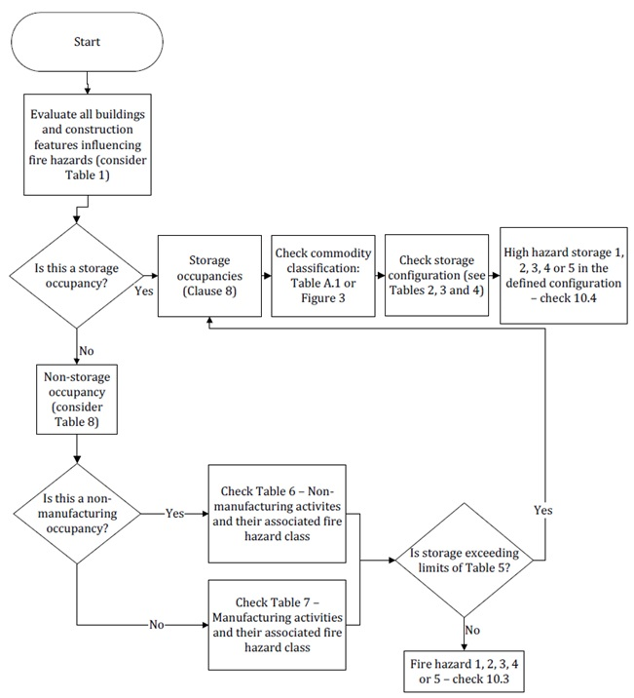

Figure 1 Methodology and process of hazard classification

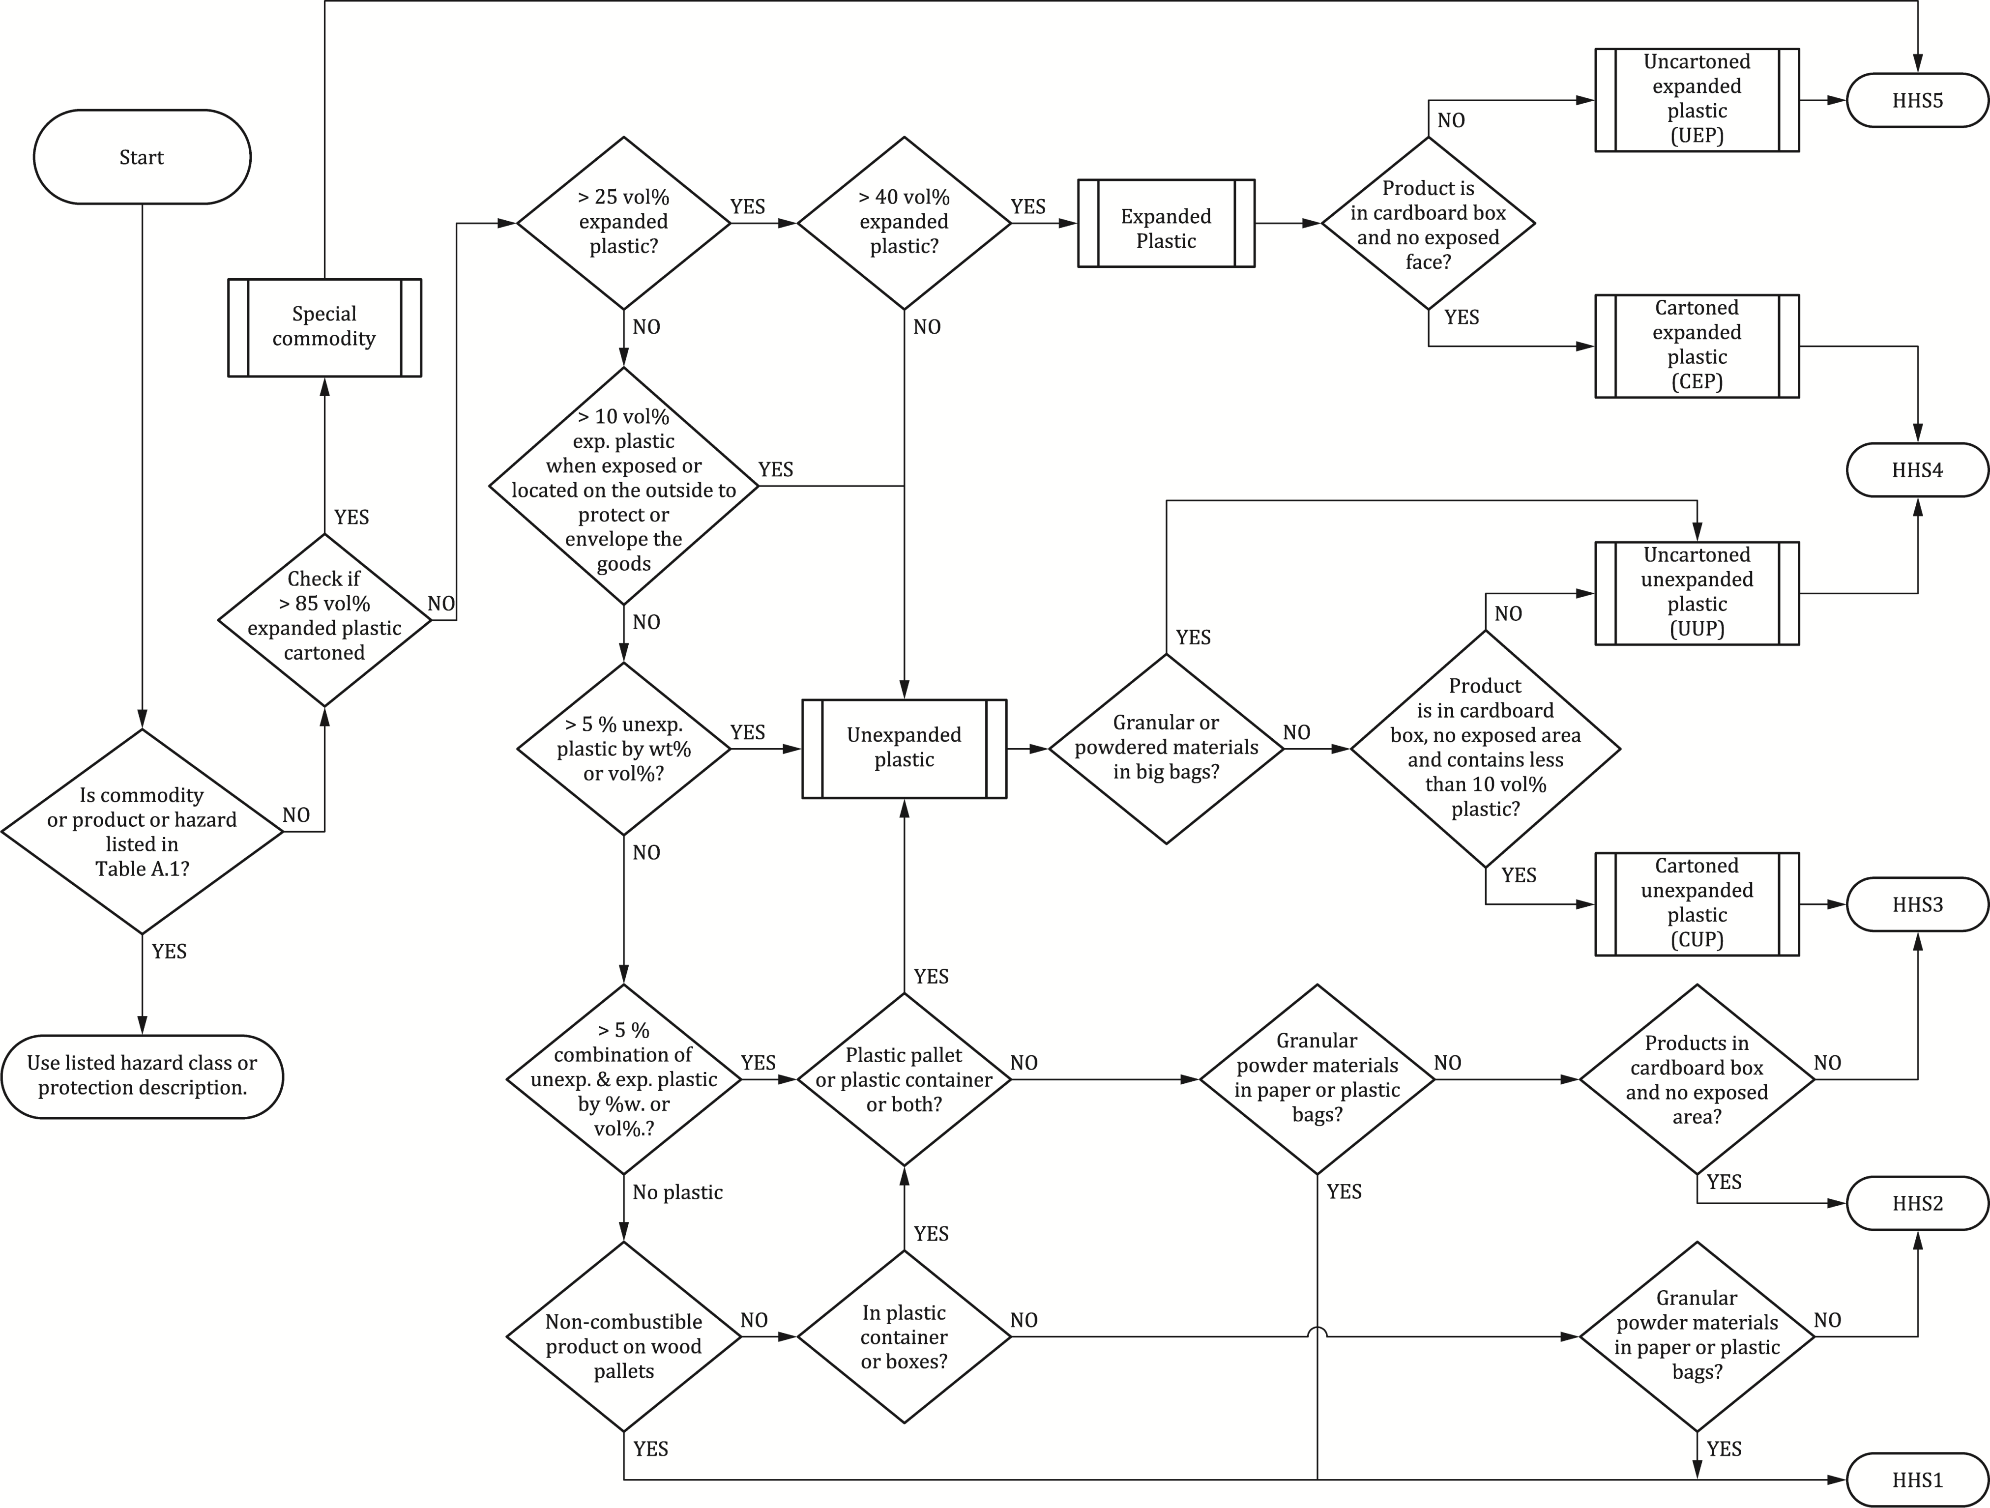

Figure 2 Fire hazard classification process for storage commodities containing plastic
The chapter on the protection of special hazards includes guidance for sprinkler systems to protect aerosol containers, clothes in multiple rack hanging garment storage, flammable liquid storage, storage in open-top containers, distilled spirits in wooden barrels and automatic car stackers. There is also guidance for the design of sprinkler systems for residential occupancies using non-residential sprinklers, the protection of high-rise buildings and for designs that make use of extended coverage sprinklers in storage and non-storage applications.

Many non-storage buildings have areas with different hazards and many different sectors of economic activity have hazards common to other activities. The revised standard recognises this and contains lengthy tables with typical hazard classes for areas, such as electrical rooms, that are found in many buildings, as well as the different hazards found within a sector, such as mashing and fermenting rooms, ammonia rooms and blow moulding of PET containers in the food and drink sector.

All of this new, detailed guidance is intended to help the user of the standard identify the correct hazard category for the sprinkler system. Without that, the design will be incorrect before any calculations have been performed!

Installation Criteria

prEN 12845-1 clarifies how to deal with obstructions, where to place in-rack sprinklers and how to protect concealed spaces. It also provides guidelines on how to deal with potential interactions between sprinkler systems and smoke control systems. Tables showing minimum pipe wall thicknesses for different pipe standards have been updated, reflecting the full range of acceptable pipe standards used across Europe. The water tank volume will in future be based on Q₁₀₀ rather than Q_{max}, reducing its minimum volume, while the maximum water velocity in the suction pipe has been increased. Both measures introduce cost savings.

New Technology and Clarifications

The current edition of EN 12845 has half a page of guidance for the protection of aerosol containers, with limited options, whereas prEN 12845-1 has over five pages with guidance for many different storage configurations and up to much greater heights. Likewise the guidance for flammable liquid storage has expanded from one page to 11 pages, again with more storage configurations to greater stored heights. The new flammable liquid guidance is largely based on testing by CNPP [6] in France. Many of the sprinkler system protection concepts for flammable liquids include foam, for which the current edition of EN 12845 does not include any guidance (see the section below). Also within the chapter on special hazards is guidance for how to protect three variations of storage configurations: picking racks with solid shelves and gangways, carton records storage with catwalk access, and automatic rack storage retrieval systems with small units (mini-load). There are also 13 pages dedicated to the design of sprinkler systems to protect distilled spirits in wooden barrels. This guidance is based FM Global research [7] which was presented to the CEN committee.

As cities grow, we are seeing more and more high-rise buildings in their centres, where land is not available. prEN 12845-1 clarifies the guidance for high-rise buildings, illustrated with improved drawings. In cities land is also not available for car parks, so we see more compact designs, such as automatic car stackers. Drawing on learning from fire tests and over 20 years of successful field experience in Germany and other countries, prEN 12845 now includes design guidance for the sprinkler protection of automatic car stackers. It also includes foam to protect against leakages of liquid fuel from the plastic fuel tank. EN 16925 [8] is the European standard for the design of sprinkler systems for residential buildings, but unless otherwise clarified in a national annex, it is only applicable to residential buildings up to 18 m high. prEN 12845-1 includes guidance on how to design residential sprinkler protection systems above that height, using either residential sprinklers or quick response sprinklers. The designs are more economical than those in the current edition of EN 12845.

Extended coverage sprinklers are a more cost-effective technology, saving on metres of pipe to be hung. 12 pages of guidance in prEN 12845-1 set out how to use extended coverage sprinklers to protect a range of fire hazards, including storage. As when ESFRs were introduced into EN 12845, we do not yet have a component standard, so CEN drafted prEN 12259-15, a component standard for spray pattern sprinklers with a k-factor above 160, extended coverage sprinklers and control mode special application sprinklers. The draft recently passed the CEN enquiry. Meanwhile EN 12259-13 has been published as the ESFR component standard.

As well as the above, we have introduced many clarifications throughout the standard, including such established areas as pipework and supports, and alarms.

Periodic Inspections

Chapter 21 in the 2015 edition of EN 12845, ‘Periodic system inspection’, is now 27.1, with the same title. It requires that the system ‘be periodically inspected by qualified personnel at least once a year.’ Furthermore, ‘it is recommended that the system inspections are undertaken by an independent body.’ In 3.151 is a definition for ‘qualified personnel’. In reality we would like to require an annual third party inspection but CEN rules do not allow standards to specify who does the work, only what must be done. We have therefore recommended that the inspection be conducted by someone independent and have clarified who is competent to conduct an inspection. In some countries an annual third party inspection is required by the government when sprinklers are installed to comply with building codes. There is evidence that these inspections lead to more reliable systems.

Corrosion Mitigation

Corrosion can threaten the performance of sprinkler systems. Countries like Germany, where all sprinkler systems are thoroughly inspected, including internally, have found that dry systems are particularly prone to corrosion. This risk can be reduced by ensuring there is a slope to drain the system after the hydraulic test, as well as by using threaded joints to prevent water accumulating in grooved connections. Nevertheless there is always water vapour in the pipe network and in combination with compressed air corrosion can be rapid. While galvanising has often been applied to prevent corrosion, field inspections have revealed that it does not help. Even worse, when wet pipe systems are galvanised the zinc can react with the water to release hydrogen. There have been several explosions. The draft of EN 12845-1 therefore does not allow galvanised pipe in wet systems and has removed the incentive of a better C-factor in the Hazen-Williams pressure loss calculation with galvanised pipe in dry systems.

Testing has shown that 98% nitrogen can greatly reduce corrosion in dry systems [9], [10]. To encourage the use of nitrogen the draft EN 12845-1 allows hydraulic calculations to use a C-factor of 120, as for wet pipe systems. A chemically bonded internal polymer also reduces corrosion to very low rates. Its surface is smoother than steel, reducing frictional pressure losses as water moves through the pipe. For these reasons a C-factor of 140 may be used with this internal protection in both wet and dry systems.

Design of Foam-Water Sprinkler Systems

Having included foam injection for sprinkler systems to protect car stackers and flammable liquids, we needed to refer to design guidance for the design of foam-water sprinkler systems. We discovered that this is not included in the European foam standards [11], which instead refer to EN 12845. We corrected that with clause 22.3.1 of prEN 12845-1, which contains guidance for the design of foam-water sprinkler systems. Among the enquiry comments were some about the phase-out of AFFF concentrates due to health concerns about fluorinated surfactants. This issue is rapidly evolving and a phase-out of AFFF concentrates now looks likely. Although at the time of writing it is unclear what timetable will be agreed, some European countries will probably move faster and soon ban AFFFs. We have therefore revised all references to foam design to be based on non-fluorinated foam. Testing has shown that while non-fluorinated foam can perform on flammable liquids, it is a less forgiving technology and requires combinations of foam concentrate and discharge device to be tested and approved for different flammable liquids. As yet there are no European test standards so we refer to UL 162 and FM 5130.

CONCLUSION

The new draft of EN 12845 has introduced many changes to bring the standard up to date with current technology. Systems designed to this new edition will be able to protect a wider range of fire challenges and will often be able to protect buildings more economically. Hazard classification will be more accurate, so that buildings and occupancies get the protection they need. A focus on long term system reliability incentivises the use of technology to make systems inherently less prone to corrosion, while detailed maintenance and testing requirements will help to ensure systems work throughout their lifetime. Separation of EN 12845 into three parts with a separate standard for pump sets will enable more focussed, timely reviews as technology and knowledge evolve. prEN 12845-1 (‘pr’ stands for ‘projet’, the French for draft) introduced many important changes, resulting in a very large number of comments at the CEN enquiry stage. It was impossible to address them within the CEN timetable so the work item has expired. Over half of the comments have been addressed. Next year a new work item will be requested and a second draft prepared for enquiry. That will be an opportunity for all the national standards bodies who make up the CEN membership to review and submit comments.

REFERENCES

[1] EN 12845:2015+A1:2019 Fixed firefighting systems – Automatic sprinkler systems – Design, installation and maintenance
[2] CEN/TS 17551:2021 Fixed firefighting systems. Automatic sprinkler systems. Guidance for earthquake bracing
[3] VdS Schadenverhütung GmbH, Cologne, Germany
[4] NFPA 13 Standard for the Installation of Sprinkler Systems, NFPA, Quincy, MA, USA, 2022
[5] FM Global Property Loss Prevention Data Sheets, FM Global, Johnston, RI, USA
[6] Groupe CNPP, Saint Marcel, France
[7] FM Global Research Campus, Glocester, RI, USA
[8] EN 16925:2018/AC:2020 Fixed firefighting systems. Automatic residential sprinkler systems. Design, installation and maintenance
[9] Corrosion Inhibition of Dry and Pre-Action Fire Suppression Systems Using Nitrogen Gas, J. Tihen, Potter Electric Signal Company, St Louis, MO, USA, 2019
[10] New Corrosion-Resistant Sprinkler Pipe, Approved Product News Volume 37 Issue 1, FM Approvals, Norwood, MA, USA, 2020
[11] EN 13565-2:2018+AC:2019 Fixed firefighting systems – Foam systems – Part 2: Design, construction and maintenance

CURRICULUM VITAE

Alan Brinson is the Executive Director of the European Fire Sprinkler Network. On graduating from Cambridge University he joined Shell as a research process engineer, moving to Proctor & Gamble before joining Tyco in 1992. With Tyco he held a series of European fire protection business and product management roles, culminating in responsibility for the European sprinkler and special hazards components business. In 2003 Alan left Tyco and set up the EFSN. For the past 20 years he has led and participated in successful sprinkler campaigns in many European countries, working with EFSN members, fire chiefs and officials to ensure that new buildings are fitted with sprinklers. Alan contributes to research to support these campaigns to bring the benefits of sprinklers to society. He is also a member of standards committees for BSI, CEN and NFPA, and is a chartered chemical engineer.

